Experiment 8: CFT (Scanning and Enumeration)
Aim: To demonstrate ethical hacking for a vulnerable machine using various tools.

Learning Outcomes:
After completion of this experiment, student should be able to

- Use various tools like netdiscover, Metasploit framework, nmap, dirb etc.
- Implement ethical hacking methodology
- Compromise vulnerable machine
Theory:
Figure 1 below indicates basic steps involved in hacking.
Reconnaissance Scanning
Gaining Access Maintaining Access
Covering Tracks
Figure 1: Basic Hacking Process

Some of the tools that you are may use in this lab are Network Scanning
  - Netdiscover
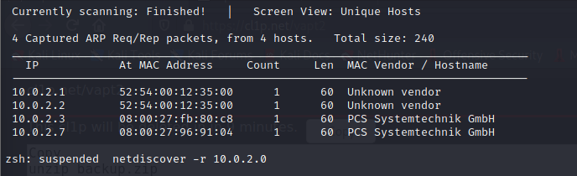
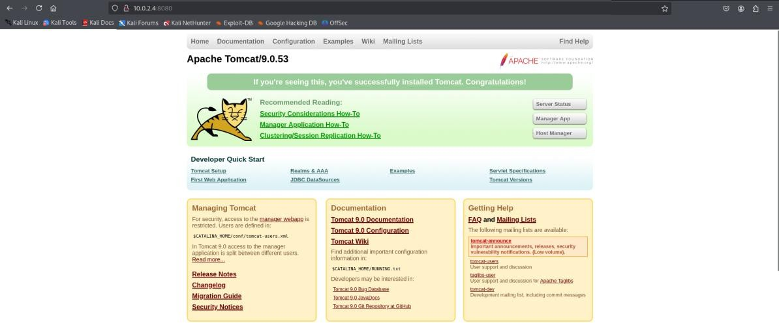
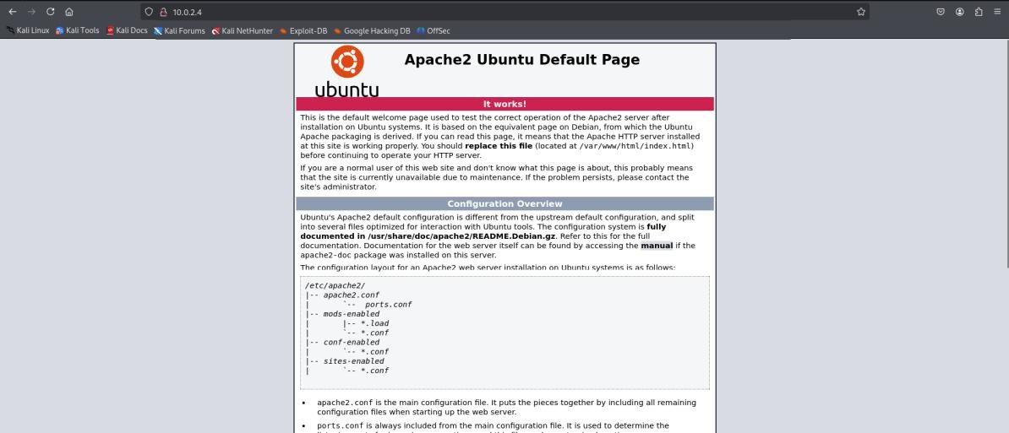
  - nmap
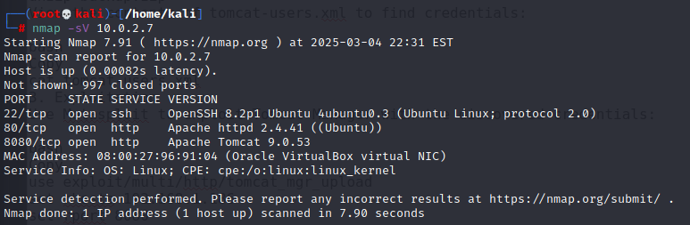
Enumeration

  - dirb
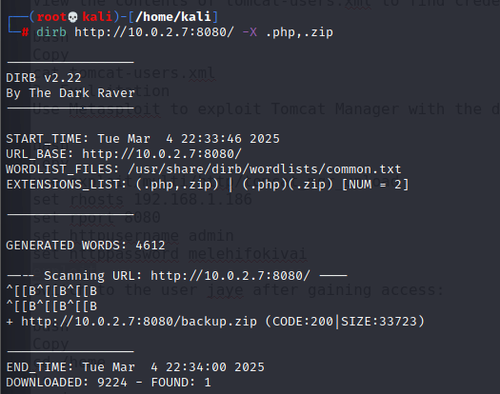

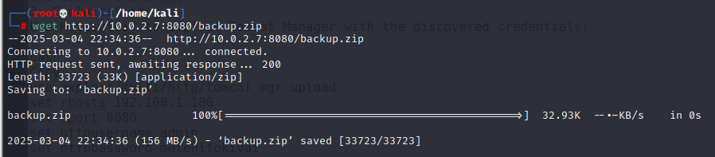

  - fcrackzip
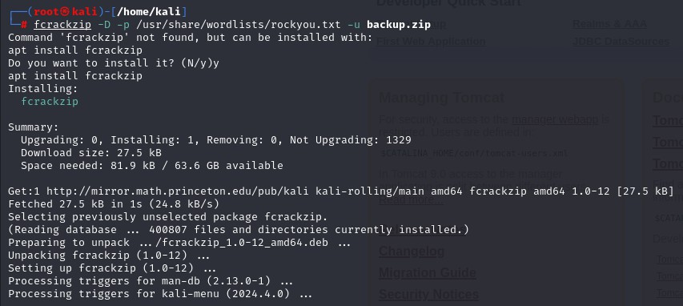

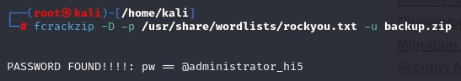
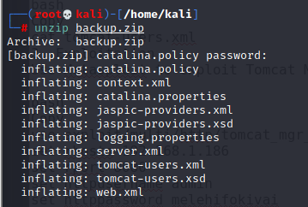

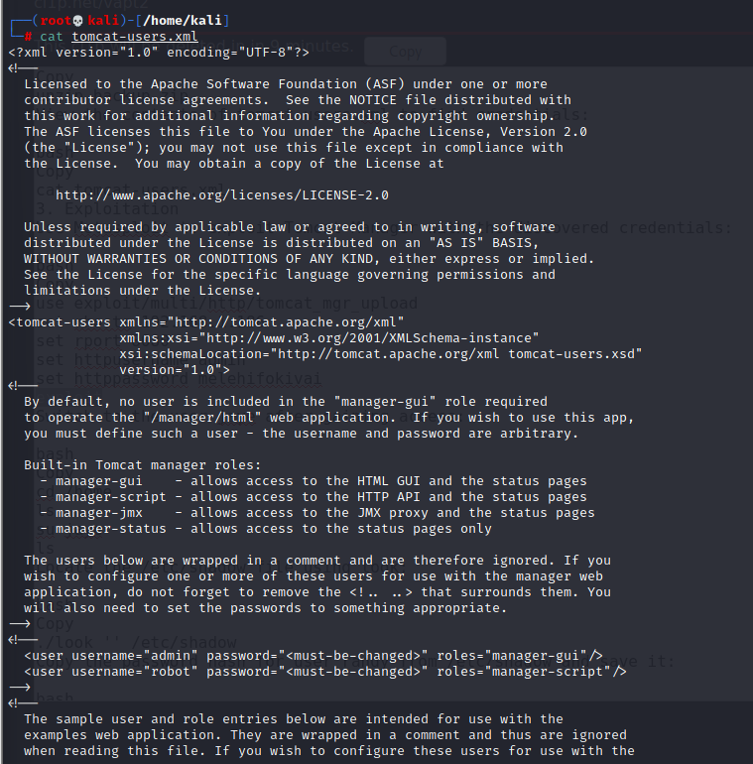

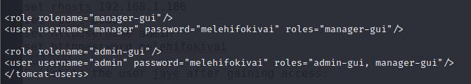
Exploitation
  - Metasploit
  - /etc/shadow
  - john
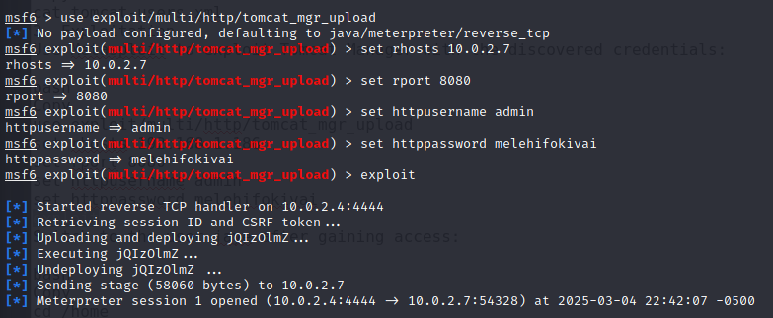

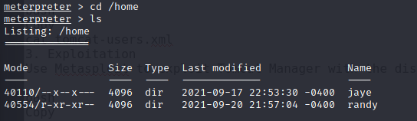
Privilege Escalation
  - ssh
  - python library hijacking
  - root flag

Procedure:
Task 1: Familiarize yourself with the above mentioned tools.
Task 2: Use the tools mentioned above to hack the vulnerable system.

Task 3: Answer the review questions and upload your document on the student portal

Review question:

1. What is the IP address of the vulnerable machine?
The IP address of the vulnerable machine is 10.0.2.7 (found using netdiscover).

2. Which ports are open on the victim’s machine?
The open ports on the victim’s machine (found using nmap) are:
Port 22: SSH (Secure Shell)
Port 80: HTTP (Apache Server)
Port 8080: Tomcat Server

3. Are there any interesting files on the server? If yes, what is the name of the file?
Yes, there is an interesting file found through directory brute-forcing on port 8080 using dirb. The file is called backup.zip.

4. If you found the file in the above Q3, is it protected? If yes, what is the password?
Yes, the backup.zip file is password-protected. The password to unzip the file is @administrator_hi5 (cracked using fcrackzip with the rockyou wordlist).

5. What is the password for the admin user?
The password for the admin user (found in tomcat-users.xml after extracting the contents of backup.zip) is melehifokivai.

Reference: https://www.hackingarticles.in/corrosion-2-vulnhub-walkthrough/

